**Department of Computer Engineering**

**Vishwakarma Institute of Information Technology, Pune**

**Software Development For Laser Marking Machine**

Janavi Shah

Prachi Panjwani

Anish Oswal

Farah Pankhania

Project Guide – Prof. Mr. Mesharam

**Table of contents**

1. **Requirement Analysis**
   1. Problem Statement
   2. Who will use this proposed system?
   3. Benefits
2. **Functional Specifications**
   1. System Overview
   2. Scenarios
3. **External Interface Specification**
   1. User interfaces
   2. Hardware interfaces
   3. Database
4. **Technical Specifications**
   1. Programming languages
   2. Versions of different components
   3. IDE to be used
   4. Performance Constraints
5. **Requirement Analysis**
   1. **Problem Statement**

To develop software for laser marking machine.

* 1. **Who will use the proposed system**

Any person who is operating on the machine (mostly buyers of the machine)

* 1. **Benefits**
* To give access to the user to control the functionality of machine.
* To reduce the manual work in marking process by automatically calibrating the positioning.
* Errors would be easily be detected and appropriate message will be generated so as to let the user know specifics about the error and correction solutions if needed.

1. **Functional Specifications**
   1. **System Overview**

There are various types of job involving marking and cutting which are done by the different machines which require a UI and hence forth enhance the user experience on operating the machine. The manual work related to the functioning of the system is very high due to which a constricted and easy UI will hide the complexities hidden and automate a lot of jobs respectively.

* 1. There are control cards assigned which control the laser head of the machine. This control card is an interface between the software and the machine wherein the hardware software communication is bridged by the input output pins. Thus, thorough examination of the I/O pins and the data can be utilized effectively and shown on a UI.
  2. The UI would provide functionalities by which the user would be able to set parameters like power, frequency, speed, calibration data for precision, etc.
  3. The job which is processed on the machine needs to be actively collected, reflected and descripted effectively and should be stored in the ERP. i.e. The status can show completed, not completed or rejected pertaining which the user can take appropriate actions to solve an issue and restart the machine respectively.
  4. All the actions performed, and data collected is abstractly displayed and information regarding alerts are also properly notified to the user.
  5. **Scenarios**

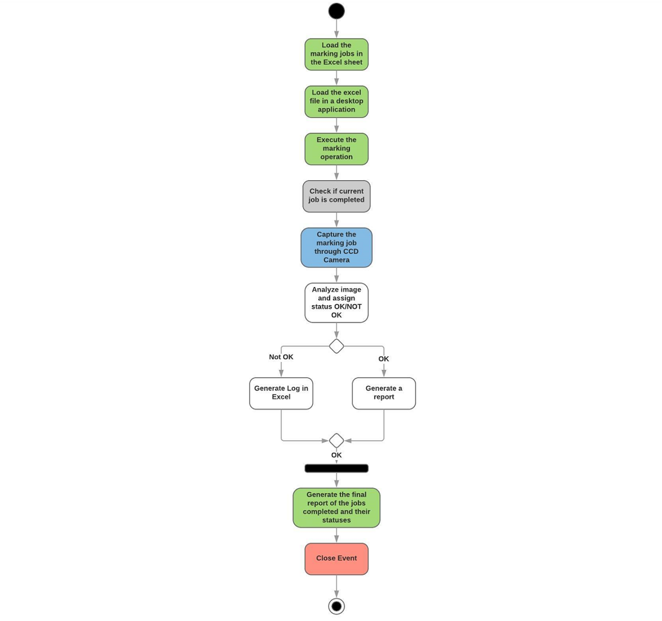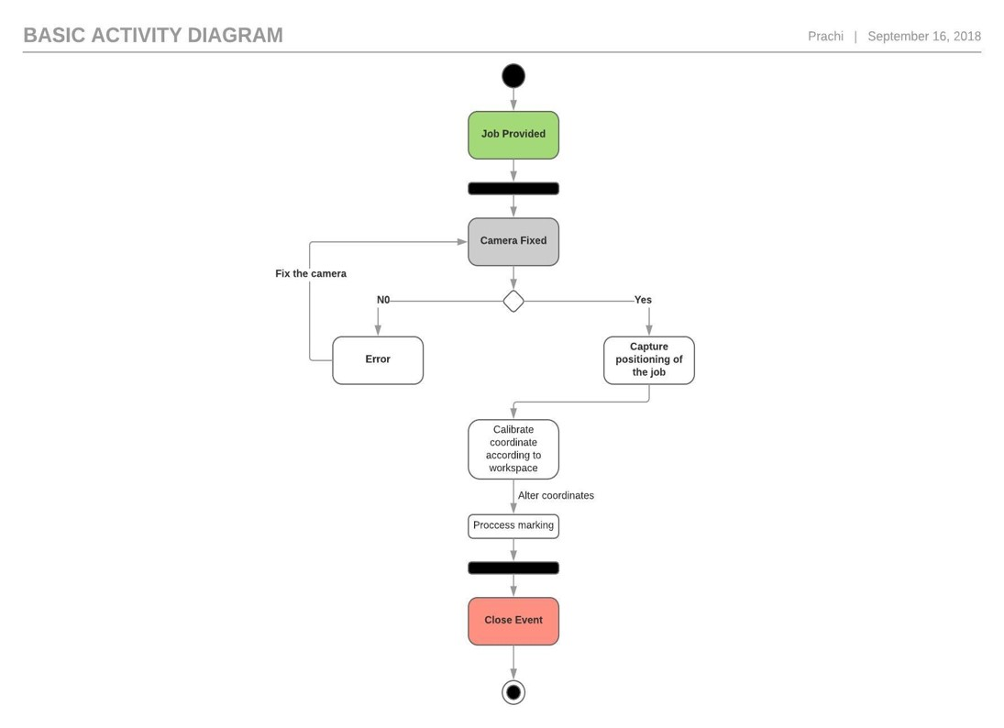

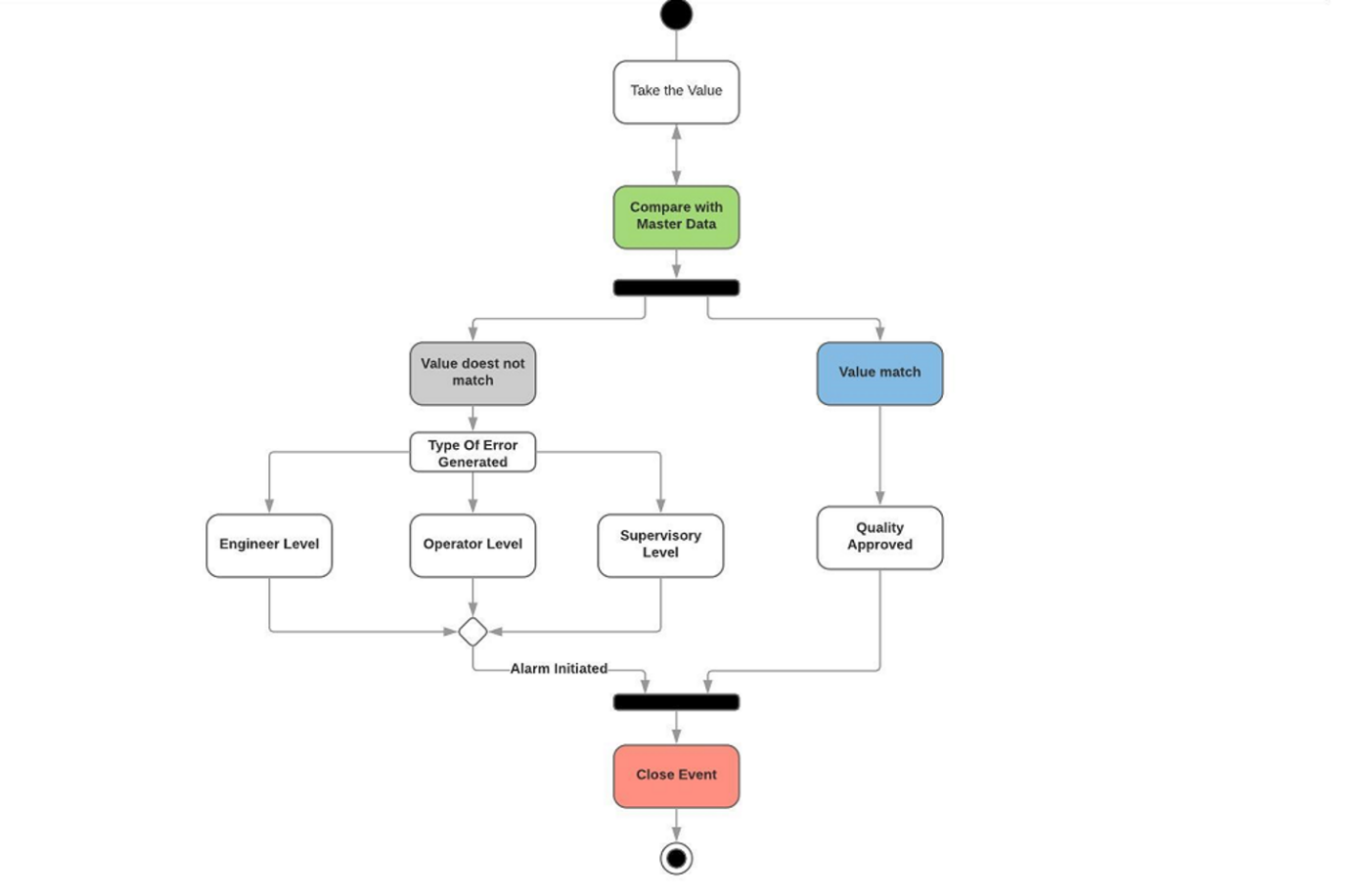

.

**3. External Interface Specification**

* 1. **User interfaces**

The user interface would provide functionalities by which the user would be able to set parameters like power, frequency, speed, calibration data for precision, etc. easily. Reports regarding the completion and the quality status would be generated in an excel file which can be used to keep records at higher authority levels. Errors would easily be detected and appropriate messages would be displayed so as to let the user know specifics about the error and correctional solutions if necessary Hence, providing a software as a front end easy to use UI, hiding the complexities would ease a lot of processes and provide more scope of automation.

* 1. **Hardware Interfaces**

SCAPS Scanner controller card is used.

2-3 Cameras to check orientation of the job

Cameras to check the quality of the mark

* 1. **Database**

We would be using local database for checking the performance of the machine and to store the data related to the machine. We might use AWS for one of the module if the project is expanded further.

**4.Technical Specifications**

Programming Languages- C#, .NET

Version of different components-

Visual Studio 2017

C# 6.0

.NET 4.5

1. IDE TO be used- Visual Studio 2017
2. Performance constraints- The following issues may limit the options available to the users:

* The excel file cannot be altered in structure.
* Camera focus may be lost.
* The laser-marking machine has stopped due to an error or power outrage during marking i.e. the marking may not be complete.
* The marking job is misaligned / irregularly shaped.
* The controller third party developer software has crashed during the process.
* The controller buffer is full and cannot instantiate more jobs.
* The hardware used to operate is outdated and hence unable to process the application.